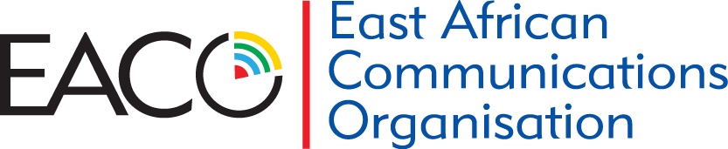
Communications for all in East Africa
REGISTRATION FORM
WORKSHOPS:
- New Technologies such as 4G/LTE, OTTS, IOTS, 13th -17th May 2019 / Kampala, Uganda
- Financial Postal Services in the digital economy, 27th -31st May 2019 / Mombasa, Kenya
The registration fees include all workshops materials, lunch and refreshments
- AUTHORIZING PERSON
Name of Authorizing Manager:____________________________________________________________________
Ministry/ Company/ : ________________________________________________________________
Designation: ___________________________________________________________________________________
Tel: ___________________________________ VAT:__________________________________________________
Postal Address:_________________________________________________________________________________
City: ____________________________Country:__________________ Post Code:___________________________
Email:________________________________________________________________________________________
Authorizing Signature: ___________________________Date:___________________________________________
By completing & signing this form, the authorizing signatory accepts the terms and conditions stated on the registration form
- DELEGATE INFORMATION
Please provide information as you wish it to appear on your name badge(s) and on your certificate of attendance.
Name: _____________________________________Position: __________________________________
Email: ___________________________________ Cell_______________________________________
Payment Date: __________________________ Your Order Number:_____________________________
Name of Person responsible for the account: ________________________________________________
Email: ________________________________________Tel: ____________________________________

- TERMS AND CONDITIONS  Cost of participation for EACO Members and Ministries are 800 USD  Cost of EACO NON-Members, Partners are 1200 USD  Bank charges will be borne by the Participants’ Organizations  - CANCELLATIONS  In the event of unforeseen circumstances EACO reserves the right to change the course content, the speakers, the venue or the date. You will be  notified no less than 5 working days prior to the workshop. Should the workshop be postponed, you will have the option to attend the next available date of the relevant event. The  registration fee will be credited on delegate accounts should they opt not to attend  the next available date of the relevant event or in the case where an event is  cancelled. | - PAYMENT  Please select your options by ticking below:  Workshop (5 days) New Technologies such as 4G/LTE, OTTS, IOTS, 13th -17th May 2019 / Kampala, Uganda  $ 800  $1200  Financial Postal Services in the digital economy, 27th - 31st May 2019 / Mombasa, Kenya  $ 800  $1200  Make payment to as per the details below:  - A/C Name: EACO (East African Communications Organization)  - Account Number: 4002200232452  - Branch: EQUITY BANK-RWANDA  - Intermediary bank: Equity Bank Kenya Ltd  - Swift Code: EQBLRWRW  - Correspondent bank: Citibank N.A. New York  - Swift Code: CITIUS33
N.B.: Please return the duly completed form one week before the workshop to EACO by e-mail to nsitati@eaco.int and emukarukundo@eaco.int

