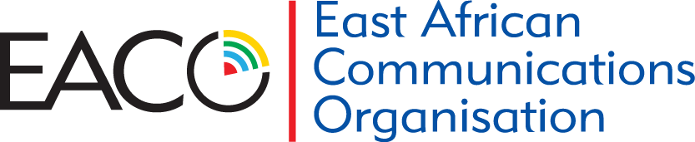

***Communications for all in East Africa***

**7TH EACO E-WASTE CONFERENCE, NAIROBI, KENYA**

**10-POINT COMMUNIQUE,**

We, members of the East African Community under the auspices of the East African Communications Organization met for three days from 24th – 26th March 2025, at Sarova Panafric Hotel, Nairobi, Kenya, and exchanged ideas and experiences in management of e-waste within our region, under the *theme* **“Advancing sustainable e-waste management in East Africa: Embracing Extended Producer Responsibility (EPR)”.**

**The following is the 10-point Declaration arising from the conference:**

1. **Enhance** percentage of e-waste being properly recycled in Africa. The conference aimed to strengthen cooperation, explore innovative solutions, and define a sustainable path forward for e-waste management in the region.
2. **Build** infrastructure for dismantling, proper disposal and recycling of e-waste.
3. **Governments** set up funding mechanisms for e-waste management.
4. Continue to **harmonize policy** and **regulatory frameworks** for e-waste management across East African countries.
5. **Facilitate** the movement of e-waste and the establishment of **a regional e-waste recycling facility**.
6. Facilitate **data sharing** and **research** to gain deeper insights into the e-waste challenge, develop effective solutions, and enhance **statistics through standardized tracking** and reporting methodologies.
7. The adoption of **emerging technologies** (AI and IoT) to enhance e-waste management.
8. **Strengthen** capacity building initiatives and **Public-Private Partnerships** and collaboration among key stakeholders.
9. **Integrate** the informal sector within a circular economy approach, recognizing its potential for economic growth and environmental sustainability.
10. **Establish** and implement **Extended Producer Responsibility** (EPR) schemes, embracing producer pays principle.

**Have an e-waste free day**