7th E-Waste Awareness Conference Speakers and Panelists Short Bios
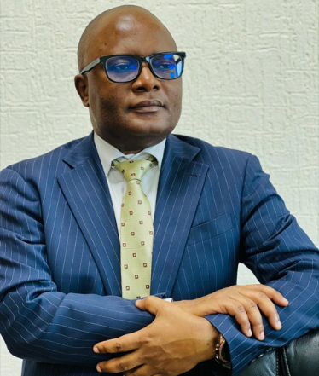
- Dr. Ally Y. Simba, Executive Director of East African Communications Organization (EACO)
EACO is a regional organisation responsible for communications sector policy harmonisation in East African region based in Kigali, Rwanda. He has more than 20 years of experience in communication industry where he has worked as an Engineer with a mobile phone operator, as a researcher, as regulator, and as policy maker with the central government of the United Republic of Tanzania.

Dr Simba received his B.Sc. (Hons.) degree in Electronics Science and Communications from the University of Dar Es Salaam, Tanzania, in 1998, and the
M.E and Ph.D. degrees in Electronics and Information Engineering from Hokkaido University, Sapporo, Japan, in 2003 and 2006, respectively
Dr. Simba was an Expert Researcher with the National Institute of Information and Communications Technology, Tokyo, Japan from 2006 to 2011, where he was involved in research on the effect of exposure from mobile phones and base stations to the human health. From 2011 to 2013, he was a Manager for Planning and Research with the Tanzania Communications Regulatory Authority (TCRA), Dar Es Salaam, Tanzania. From 2013 to 2015, he served as a Director of ICT at the Ministry of Communication Science and Technology (MCST) of the United Republic of Tanzania and later appointed to the position of Director General of TCRA in July 2015, a position he served until December, 2016. Dr. Simba has published widely in peer-reviewed international journals and presented his research work in more than 30 international conferences. He participated actively in the work of the Study Group 5 of the International Telecommunication Union (ITU) since 2009.
Dr. Simba is a Chartered Engineer, registered with the U.K. Engineering Council and a Fellow of the Institution of Engineering and Technology, U.K., where he served an International Professional Registration Advisor for Engineering Professional Registration from April 2011 to March 2014. He is also a Senior Member of the Institute of Electrical and Electronics Engineers (IEEE).
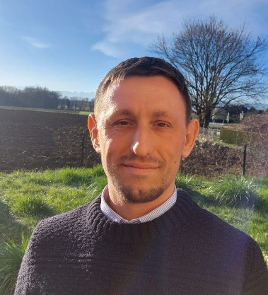
- Garam Bel
Garam Bel is the Circular Economy Coordinator for the Telecommunication Development Bureau (BDT) of the International Telecommunication Union based in Geneva. He coordinates the electronic waste projects in BDT covering regulatory development and data collection. Prior to joining ITU, he worked for the Environment Management Group which is a United Nations system-wide coordination body on environment and human settlements. In this position, he ran activities towards streamlining the various electronic waste related initiatives of UN agencies and programmes. Before moving to Geneva, Garam worked for local government in Scotland in the area of municipal solid waste. He holds a
master’s degree in Standardization, Social Regulation and Sustainable Development from the University of Geneva.
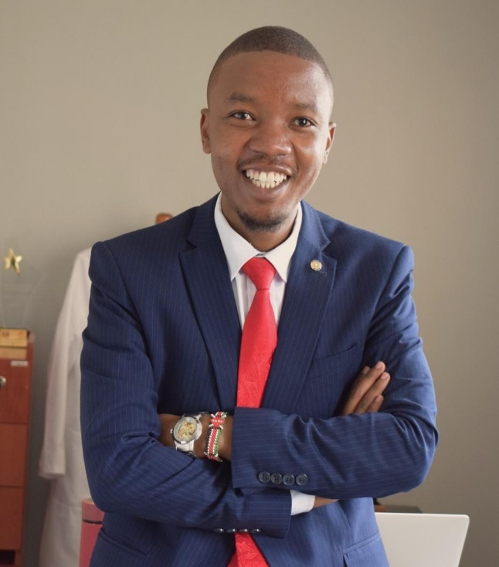
- Bonnie Mbithi
CEO WEEE Centre | Executive Director CFSK
Bonnie is a successful climate-tech and circular economy entrepreneur solving global challenges through innovation with a demostrated history of working in the ICT, NGO and services industry.

He is the co-founder at the WEEE Centre which is the premier and leading E-waste recycling company that has managed over 10,000 tones of e-waste in an environment friendly manner.

- Neirin Jones, MSc
Mr. Neirin Jones is an EPR Consultant at Black Forest Solutions, Chief Executive Officer of Green Forest Solutions, and Director of GFS East Africa, establishing EPR schemes for;
- waste plastic packaging
- waste electrical and electronic equipment
- waste batteries
- waste textiles in emerging markets.

Since 2015, the group has provided systemic and sustainable waste management solutions, empowering businesses, governments, and communities in over 100 countries globally.

Neirin Jones offers the audience an understanding of the operations and unit economics of EPR to support the industry’s smooth transition into a sustainable circular economy.
www.gfs.earth
info@gfs.earth
www.linkedin.com/company/gfs-earth
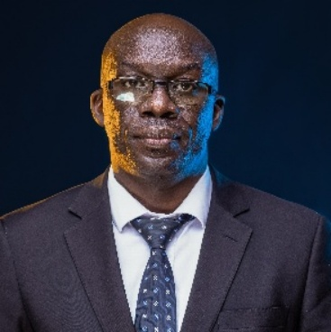
- Michael Ocero
Chairperson Regional E-waste Steering Committee Chairperson Uganda National E-waste Steering Committee Head of Department of E-services, Ministry of ICT and National Guidance, Uganda.

- Ms. Beatrice Msenga is an Environmental Officer within the Pollution Section of the Vice President's Office – Division of Environment, Tanzania. Holding a Bachelor's degree in Environmental Science and Management, and a Master's degree in Biodiversity in Ecosystem Management, she contributes to the development and implementation of environmental policies and programs, with a focus on pollution control.


- Ms. Sara Njau is the Managing Director of GFS East Africa. GFS East Africa is a purpose-driven organization established in 2024, committed to empowering businesses in East Africa to navigate the complexities of environmental responsibility and unlock the value of the circular economy.


- Niels Peters Williams (Mr.)
Niels Peters Williams is an Associate Programme Officer at the UN Office on Drugs and Crime (UNODC), with expertise in maritime and environmental crimes. Based at the UNODC Regional Office for Eastern Africa in Nairobi, Niels leads the Environment Team's work on climate change, coordinating UNODC’s engagements within the UN Climate Change Conference and other Multilateral Environmental Agreements, and driving efforts to integrate justice system responses to environmental crime into global action on climate, biodiversity and pollution.
Before joining UNODC, Niels worked at the UN Environment Programme (UNEP) in Kenya, where he specialized in biodiversity restoration.
Niels is a national of Ecuador and holds an undergraduate degree in International Relations from the University of Edinburgh, as well as a Master’s degree in International Development and Humanitarian Emergencies from the London School of Economics and Political Science.

- Dr. Jackson Koimbori
Head of KEPSA Consult & Senior Circular Economy and Climate Change Coordinator
Kenya Private Sector Alliance (KEPSA) | Email: jkoimbori@kepsa.or.ke
Dr. Jackson Koimbori is a seasoned expert with over 11 years of experience in climate change, carbon markets, climate finance, agriculture, renewable energy, WASH (Water, Sanitation, and Hygiene) and GIS. He currently heads the KEPSA Consult, Circular Economy and Climate Change department at the Kenya Private Sector Alliance, after holding significant roles at Bodhi Global Analysis, EED
Advisory, and Climate Change Kenya Organization. His expertise includes business development, project management, policy formulation, greenhouse gas inventories, carbon markets, and stakeholder engagement, with a focus on climate adaptation and mitigation strategies. Dr. Koimbori has worked on projects for major international organizations such as UNDP, UNICEF, FAO, and the World Bank Group, and has contributed to the development of key environmental policies in Kenya. His research, focused on agriculture, water, and climate change, has been widely published, and he has utilized tools such as Climate Modeling Software’s, DSSAT, GIS, and MATLAB in his work. He holds a Bachelor’s degree in Educational Science, Biology and Geography from Egerton University, two Master’s degrees in Earth Science and Climatology, from Uppsala University and Kenyatta University respectively and a PhD in Agricultural Meteorology and Climate Change from the Chinese Academy of Agricultural Sciences.
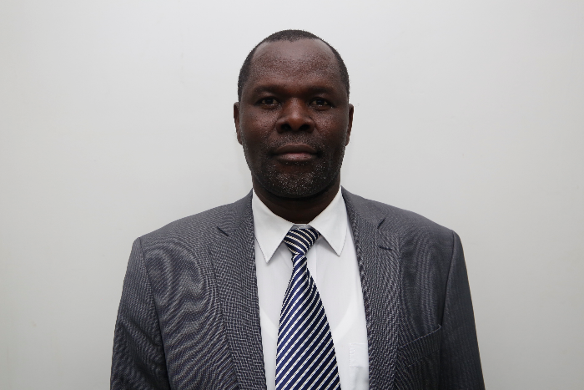
- Mr. Juma Ooro
Acting Deputy Director/Consumer Protection & Advocacy, Communications Authority of Kenya (CA)
Juma is a University of Nairobi trained Economist (Master of Arts in Economics) and is in charge of Consumer Protection and Customer Service at Kenya’s ICT Regulator, the Communications Authority of Kenya (CA). He has worked at CA for 19 years. Previously, he worked at Kenya’s Competition Regulator, now the Competition Authority of Kenya for over 10 years.

Mr. Ooro is a former Chairperson of East African Communications Organisation’s (EACO) Working Group 07 on E-waste Management and
Green ICTs, having served for 10 years. He is also a member of the International Telecommunication Union (ITU) Study Group 12 that deals with Performance, Quality of Service and Quality of Experience and Study Group 5 that deals with Environment, EMF, climate action and circular economy. He achieved many milestones while at the helm, including, putting in place a regional Model Framework on E-waste Management and Regional E-waste Management Strategies.

- Eric Guantai
Eric G. is a climate policy and environmental governance specialist, passionate about advancing sustainable resource management and driving social equity through circular economy models. My work focuses on bridging the gap between climate action, informal waste sectors, and inclusive economic development, particularly in emerging markets.
With years of experience facilitating multi-stakeholder partnerships across governments, international agencies, private sector players, and civil society, he specialize in designing climate-resilient interventions that position waste as a key resource for sustainable cities and communities. My mission is to support waste actors—both formal and informal—across upstream and downstream value chains to thrive within circular economy ecosystems.
I am especially committed to integrating informal waste enterprises into formal circular supply chains, promoting Extended Producer Responsibility (EPR) compliance, and reducing Scope 3 emissions through innovative waste-to-value solutions. I’ve been privileged to lead capacity-building programs that empower community-based waste enterprises to access EPR funds, circular economy financing, and business enablers while aligning with global ESG standards.
As an advisor to governments, development organizations, and private entities, I advocate for enabling policy and regulatory frameworks that foster environmental justice, climate resilience, and inclusive economic models.
My work contributes directly to global sustainability and climate targets, with a strong focus on advancing the Sustainable Development Goals (SDGs), particularly SDG 11, SDG 12, and SDG
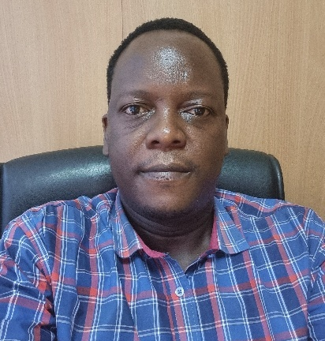
- Derick Simiyu Khamali
Principal Officer/Telecommunications Compliance and Enforcement Department, Communications Authority of Kenya (CA).
Vice Chair - ITU-T SG5 on ICT Environment, E-waste and Circular Economy.

Derick is a Regulatory Officer handling matters on Telecommunications Compliance and Enforcement. The responsibility covers study and detailed grasp of the licensing, standards and the legal requirements for the regulated sector. The operations touch on Compliance to the Electromagnetic Fields, Circular Economy, Sustainability and Environmental Protection. Has experience
in assessing the industry performance in terms of Quality of Service and Consumer Protection. He is passionate on matters of Ewaste management, Environment sustainability and material science in information systems and technology.

Derick has developed compliance templates that the ICT industry in Kenya uses to self-audit on environmental sustainability and compliance to ewaste management. The licensed entities provide compliance and operational reports that affect the actions undertaken, safety measures and protection of exposure of consumers to elctromagnetic effects. The deployment must be controlled to ensure that there’s adherence to the set standards and that unique occurrences are mapped out to help entities meet the targets set with full compliance. Failure to comply leads to application of enforcement measures,

Derick is an active member of the East Africa Communications Organization (EACO) working groups on E-waste Management and the other one is Quality of Service/Consumer Protection and Cyber Security. He was part of the technical team that developed the inaugural E-Waste management Strategy that aims to achieve Zero Negative Impact of E-Waste in the East African region.

He is an active member and vice chairman of ITU-T Study Group 5 which is responsible for the development of standards on the environmental aspects of ICT and digital technologies and protection of the environment, including electromagnetic phenomena and climate change. He follows similar ITU-T SG5 activities at the Regional Group for Africa where the target is to domesticate the global phenomena into local solutions. He has the leadership qualities that will fit and surpass expectation.
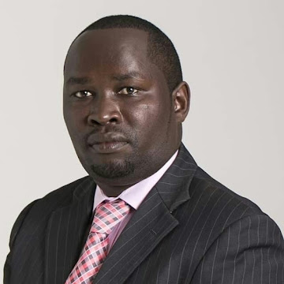
- Lawrence Thuo
Lawrence Thuo, an ICT, e-waste expert, trainer, businessman. The founder and Executive Director of E-Waste Initiative Kenya (EWIK) and E-waste Technical Academy, boasts 23 years in ICT and waste management. His career has been marked by pioneering e-waste management solutions, forging key partnerships, and advocating sustainability. With a strong academic background in electrical and electronics engineering, Lawrence is at the forefront of Kenya's circular sustainability movement. His leadership sets new standards for responsible e-waste practices, shaping a greener future in Kenya and globally. He has a passion for gender mainstreaming and an authority in the One Health Approach in informal e-waste sector.

- Mariana Daykova is an experienced program manager and consultant in the sector of decentralized
renewables and e-waste management in developing and transitional economies, with a business, policy and operations focus. She is currently working as a manager for dss+, a global operations consultancy advising on health and safety, operational excellence, and sustainability. Her current focus is on e-waste policy development and off-grid solar e-waste management, all in Africa and for international donors, private sector, and government clients.

- Ms. Jackline Wanja
Ms. Jackline Wanja Wanjiru is a Programme Management Officer in the Legal and Policy Unit of the Secretariat of the Basel, Rotterdam, and Stockholm Conventions.
She has a decade of experience in legal guidance, legal review, and legal research on environmental matters, including on the implementation and enforcement of multilateral environmental agreements. Her background also includes work in trade and human rights within civil society organizations.
Ms. Wanjiru holds an LL.M. in International Law from the Geneva Graduate Institute in Switzerland and is an Advocate of the High Court of Kenya.


- Bancy Wawira Ireri
Bancy is a professional with degrees in Biochemistry, Project Management, and Strategic Management. Her extensive career spans over 10 years in roles across public, private, and informal sectors, with a strong focus on achieving Sustainable Development Goals. Currently, she holds an administrative position at a public university in Kenya, where she continues to contribute to her field.

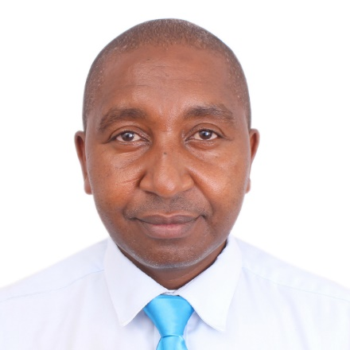
- STEPHEN KAMUNGE MBUGUA
Stephen Kamunge Mbugua is a professional with a Master's degree in Entrepreneurship and a Bachelor's degree in Economics. With over a decade of experience, he is an accomplished senior researcher and startup trainer. Currently, he holds the position of Center Manager at E-wik Innovation Hub, where he plays a pivotal role in overseeing and managing operations related to innovation and entrepreneurship. Stephen's wealth of expertise and experience positions him as a valuable asset in the realms of business and innovation.
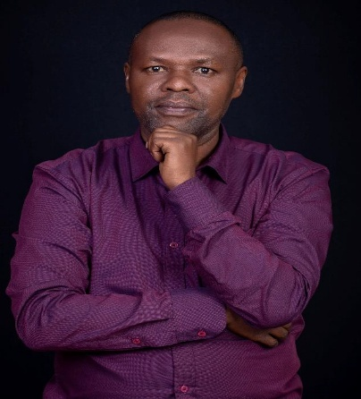
- Michael Koech, Environment and Social Lead, Airtel Africa
Michael is a seasoned Sustainability, Safety, and Environment practitioner with extensive expertise in sustainable and responsible business practices. He has a proven record of integrating sustainability principles into corporate strategy and operations. Michael specialises in environmental policy, climate change strategy, and thought leadership on emerging sustainability trends across the telecommunications, manufacturing, and agricultural sectors.

With over 20 years of corporate sustainability experience, Michael began his journey at Unilever before advancing to roles at Savannah Cement, Safaricom,
GSMA, and currently, Airtel Africa. In his capacity as Group Environment and Social Lead at Airtel Africa, Michael is responsible for developing and implementing the environmental and social pillars of the company’s sustainability strategy across 14 African markets.
In addition to his professional endeavors, Michael contributes to industry leadership as a member of the KEPSA Environment Sector Board and the Kenya’s National Steering Committee on electrical and electronic.

In addition to his professional endeavors, Michael contributes to industry leadership as a member of the KEPSA Environment Sector Board and the Kenya’s National Steering Committee on electrical and electronic waste (E-Waste) management. His dedication to sustainability extends beyond his work, reflected in his personal passion for tree planting and advancing the principles of a circular economy.

- VALENTINE J. CHERUIYOT
Valentine Cheruiyot is a seasoned sustainability specialist with over 10 years of experience in steering decarbonization, ESG integration, Environmental management system implementation, promoting circular economy principles in resource management, risk management, ecosystem restoration, and regulatory monitoring and compliance.
Currently she works with Safaricom as the lead for Climate Change and Environment. Over the years in her career life at National Environemnt Management Authority and now at Safaricom she has acquired wealth of knowledge, skills and competence in strategic leadership, Green House Gas accounting, corporate net-zero target setting, environmental management tools, and sustainability disclosures frameworks and standards.

She was recently nominated as the Vice-chair, Electronic waste Producer Responsibility Organization (EPROK) Board of Directors to support with effective support, coordination and growth of EPROK Membership.

She holds master’s degree in environmental policy from University of Nairobi and bachelor’s degree in environmental science from Kenyatta University and a diploma in project management from Kenya Institute of Management.

She is a certified Sustainability practitioner, EMS lead implementer and auditor and Environmental Social Impact and Audit expert.
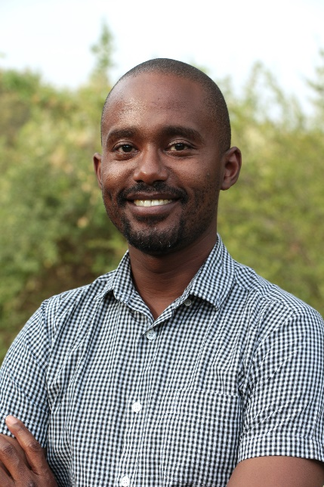
- Alvin Gachie is a Legal Officer in the Law Division of the United Nations Environment Programme (UNEP), specializing in climate change, pollution, and nature loss. Based at UNEP headquarters in Nairobi, Kenya, Alvin provides technical legal assistance to governments, supporting the development and implementation of international environmental law.
Before joining UNEP, Alvin worked at the Office of the High Commissioner for Human Rights (OHCHR) in Geneva, Switzerland, focusing on the intersection of human rights and the environment, particularly in relation to chemicals and wastes. Aside from his work on environmental law and governance, Alvin has also worked in the fields of sustainable development, human rights, and humanitarian law. He has also worked in international civil society and the private sector.
Alvin is qualified to practice law in Kenya and holds a Master’s degree in law and a Bachelor’s degree in law from the University of Nairobi.
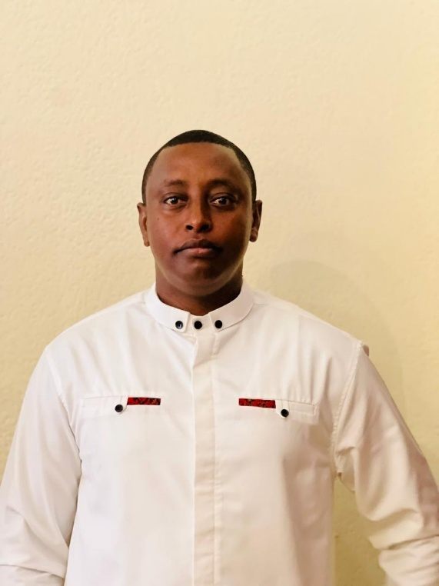
- Steven KARAKE is the head of quality research assurance at the Rwandan private sector federation. He has over 8 years of experience in research, project management, business development, and waste management.

- Ms. Hanna Dittmeyer works as Head of the Competence Centre Energy, Environment and Sustainable Economy at the AHK Services Eastern Africa Ltd., a service entity of Delegation of German Industry and Commerce for Eastern Africa. As such, she is connecting German and East African private sector in the mentioned sectors and topics, including renewable energy, energy efficiency, water management, circularity and waste management, e-mobility and green hydrogen. The AHK serves as knowledge and market information hub for Eastern Africa and Germany providing information to companies and stakeholders as private consultancy firm.

- Ms. Linah Ngumba, Statistician, Kenya National Bureau of Statistics
Linah Ngumba works for the Kenya National Bureau of Statistics, which is the country's National Statistics Office (NSO). She is in charge of the ICT statistics section, which is in charge of conducting nationwide ICT-related studies and analyses in the country. She pioneered the ICT statistics chapter in the Economic Survey report, ICT enterprise and public institution surveys, and an ICT module in the 2019 Population Census. Ms Linah is the current Chair of the International Telecommunication Union's Expert Group on ICT Household Indicators (ITU). She has a master's degree in communications management, a master's degree in economics, and a bachelor's degree in economics and statistics.

